Information Retrieval — Unit 4 Exam Answers
Exam Unit 4 (Q7/Q8) = Syllabus Unit VI: IR Applications — Multimedia IR & Recommender Systems

Unit Snapshot
No. | Question | Max Marks | Years Asked | Importance
4.1 | Four phases of recommender system | 9 | N23, M24, N24, N25 | ★★★
4.2 | Multimedia Information Retrieval / multimedia IR models | 9 | N23 (×2), M24, N24, N25 | ★★★
4.3 | Difference between information retrieval and recommender system | 9 | N23, N24, N25 | ★★★
4.4 | Evaluation metrics for recommender systems | 10 | M24, N24, N25 | ★★★
4.5 | Steps to build a recommender system with an example | 10 | M24 | ★ (high marks)
N23 = Nov–Dec 2023, M24 = May–Jun 2024, N24 = Nov–Dec 2024, N25 = Nov–Dec 2025. Source file for all citations: Textbooks/IR Sem7.pdf (“PDF p.” = page of the PDF, “§” = section number in the notes).

Must-Do First (★★★)
- 4.1 Four phases of recommender system
- 4.2 Multimedia IR and its models
- 4.3 IR vs recommender system
- 4.4 Recommender evaluation metrics
Exam strategy: Since N24, Q7 = 4.2 + 4.1 and Q8 = 4.4 + 4.3 (9 marks each). All four ★★★ answers cover this whole unit. Answers are written for 11–12 marks, so they are the longest in the set — write the diagram + table first, then the points.

Full Answers

4.1 What are the four phases of recommender system? ★★★
Write for: 11 marks (asked max 9) · Asked in: N23 Q7b [9], M24 Q7b [8], N24 Q7b [9], N25 Q7b [9] · Source: Recommender basics in IR Sem7.pdf, PDF p.53–57 (§6.2 Recommendation Systems, §6.2.1 Collaborative Filtering, §6.2.2 Content Based, §6.3 Knowledge Based). The “four phases” list itself: ⚠ Not found in your materials — standard textbook answer.

Definition
A recommender system (RS) is an information-filtering system that predicts a user’s preference (rating) for items and suggests the most relevant items (movies, products, news) without an explicit query. E.g. Netflix, Amazon, YouTube.

The four phases
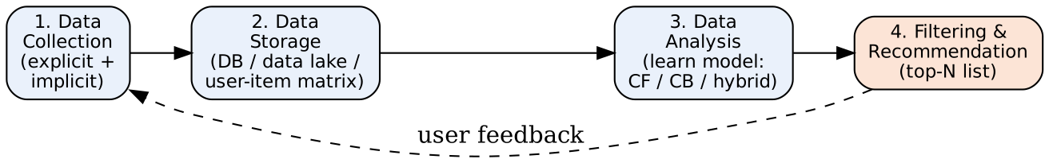
Phase 1 — Data Collection (Information collection)
- Gathers information about users, items and interactions to build the user profile.
- Explicit feedback: ratings (1–5 stars), likes, reviews, surveys.
- Implicit feedback: clicks, views, purchase history, watch time, search queries, dwell time.
- Item data: title, genre, description, price (for content-based); context: time, location, device.
- Problem: cold start for new users/items with no data.
Phase 2 — Data Storage
- Collected data is stored so it can be analysed efficiently: relational DB (structured ratings), NoSQL / data lake (logs, clickstreams), user–item rating matrix.
- Choice of storage depends on volume, velocity and type of data; the matrix is usually sparse (users rate few items).
Phase 3 — Data Analysis (Learning phase)
- A learning algorithm finds patterns and similarities and builds a model:
  - Collaborative filtering (CF): “users similar to you liked this” — user-based / item-based similarity (cosine, Pearson), matrix factorisation.
  - Content-based filtering (CB): match item features with the user’s profile (TF-IDF of descriptions).
  - Knowledge-based: rules/constraints from the user’s explicit requirements.
  - Hybrid: combination (Netflix).
- Analysis can be real-time, near-real-time or batch.
Phase 4 — Data Filtering & Recommendation (Prediction phase)
- The model predicts ratings/scores for unseen items, filters already-seen or unavailable items, ranks them and shows the top-N recommendations.
- Filtering methods: content-based, collaborative, hybrid; predicted rating e.g. ru,i=ru+v​simu,vrv,i−rvv​ǀsimu,vǀ
- User reactions are fed back to Phase 1 → system keeps improving.

Component explanation (diagram)
- Collection → input signals; Storage → organised data; Analysis → trained model; Filtering & recommendation → output list; dashed arrow → continuous feedback loop.

Example (Netflix)
- Collect: you rate Inception 5★, watch 3 sci-fi films. 2. Store: ratings in user–item matrix, logs in data lake. 3. Analyse: users similar to you also liked Interstellar. 4. Recommend: Interstellar appears in “Because you watched Inception”.

Applications
E-commerce (Amazon), OTT (Netflix, Hotstar), music (Spotify), news feeds, social media friend suggestions, e-learning course suggestions.

Conclusion
A recommender works in four phases — Collect → Store → Analyse → Filter/Recommend — with user feedback looping back to improve future recommendations.
Memory trick: “CSAF” → “Can Someone Advise Films?” = Collection, Storage, Analysis, Filtering. Mention explicit vs implicit feedback — examiners expect it.

4.2 Multimedia Information Retrieval / Explain multimedia IR models. ★★★
Write for: 11 marks (asked max 9) · Asked in: N23 Q7a “Explain multimedia IR models?” [9] and Q8a “Multimedia Information Retrieval” [9], M24 Q8a [8], N24 Q7a [9], N25 Q7a [9] · Source: IR Sem7.pdf, PDF p.48–53 (§6.1 Multimedia Information Retrieval — key components; §6.1.1 Spoken Language Audio Retrieval, §6.1.2 Non-Speech Audio Retrieval, §6.1.3 Graph Retrieval, §6.1.4 Imagery Retrieval, §6.1.5 Video Retrieval with colour-histogram Python example). Model classification (text-based / content-based / feature-vector, probabilistic, MPEG-7): partly standard textbook.

Definition
Multimedia Information Retrieval (MIR) deals with the retrieval, organisation and analysis of multimedia data — text, images, audio, video, graphics — so that users can search, access and analyse multimedia content efficiently (notes). Used by search engines, recommendation systems and digital libraries.

1. Key components of MIR (notes)
- Data representation: images/videos as feature vectors or histograms; audio as spectrograms or MFCCs (Mel-Frequency Cepstral Coefficients).
- Indexing and retrieval: inverted files, tree-based indexes (R-tree, k-d tree), hashing for fast similarity search.
- Content-based retrieval: finds items similar in visual/audio features, not metadata.
- Text-based retrieval: uses keywords, captions, tags, metadata.
- Multimedia analysis: object recognition, speech recognition, emotion and scene detection.
- Relevance feedback: user marks relevant/irrelevant results to refine search.
- Evaluation metrics: precision, recall, F-measure.

2. Multimedia IR models
(a) Text-based (metadata / annotation) model
- Multimedia objects described by text (file name, caption, tags, surrounding web text); then classic IR (Boolean, vector, probabilistic) is applied.
- Simple and fast, but needs manual annotation; subjective and incomplete.
(b) Content-based (CBMR) model — feature-vector model
- Extract low-level features automatically: colour (histogram), texture (Gabor, GLCM), shape (edges, contours), motion (video), pitch/rhythm/MFCC (audio).
- Each object = point in a feature space; query by example (QBE) or sketch.
- Similarity = Euclidean distance dq,o=i​qi−oi2 or cosine similarity; results ranked by similarity (k-NN search).
(c) Probabilistic / learning-based model
- Estimates P(relevant | features) using Bayesian or deep learning models (CNN embeddings for images, speech-to-text for audio); bridges the semantic gap.
(d) Structured / data model (e.g. MPEG-7)
- Standard descriptors & description schemes for multimedia content (colour, shape, motion, audio descriptors) + query languages supporting attribute and similarity predicates.
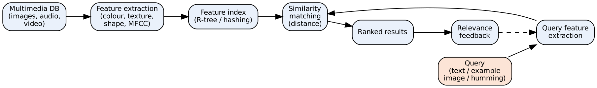
- Multimedia DB: stored media objects. Feature extraction: converts each object into a numeric descriptor (offline).
- Feature index: multidimensional index for fast search.
- Query & query features: user query converted to the same feature space.
- Similarity matching: computes distance between query and stored features. Ranked results → relevance feedback refines the query.

3. Types of multimedia retrieval (notes §6.1.1–6.1.5)
Type | How it works | Example
Spoken language audio | Speech recognition (ASR) → text → index; keyword spotting | Podcast / lecture search
Non-speech audio | Acoustic features (MFCC, pitch, rhythm), audio fingerprinting | Shazam, query-by-humming
Graph retrieval | Match graph structure/sub-graphs (nodes, edges) | Chemical structures, knowledge graphs
Imagery (image) retrieval | Colour, texture, shape features; CNN embeddings | Google Lens, reverse image search
Video retrieval | Shot/scene detection, key frames, motion, audio + captions | YouTube search, CCTV analysis

4. Challenges
Semantic gap (low-level features ≠ high-level meaning), high dimensionality, huge storage, subjectivity of similarity, multimodal fusion, copyright.

Example
User uploads a photo of a red rose → system computes its colour histogram → finds images with closest histograms (Euclidean distance) → returns top-10 similar flower images; the notes’ Python example does the same for videos using OpenCV colour histograms + cosine similarity.

Conclusion
MIR retrieves non-text media using text-based and content-based (feature-vector) models plus probabilistic/deep models; it covers speech, audio, graph, image and video retrieval, with the semantic gap as the main challenge.
Memory trick: Types = “SNGIV” → “Some Nice Girls In Videos” = Spoken audio, Non-speech audio, Graph, Image, Video. Models = T-C-P-S: Text, Content, Probabilistic, Structured (MPEG-7).

4.3 What is the difference between information retrieval and recommender system? ★★★
Write for: 11 marks (asked max 9) · Asked in: N23 Q8b, N24 Q8b, N25 Q8b (all 9 marks) · Source: ⚠ Not found in your materials (no comparison in notes). Standard textbook answer; definitions consistent with IR Sem7.pdf, PDF p.53 (§6.2 Recommendation Systems).

Definitions
- Information Retrieval (IR) system: finds documents relevant to an explicit user query from a large collection and returns a ranked list (e.g. Google Search). It is pull-based — the user asks.
- Recommender System (RS): predicts and suggests items a user may like without an explicit query, using the user’s past behaviour, preferences and similar users (e.g. Netflix). It is push-based — the system offers.

Difference table
No. | Basis | Information Retrieval | Recommender System
1 | Input | Explicit query (keywords) | User profile / history, no query needed
2 | Interaction mode | Pull — user actively searches | Push — system proactively suggests
3 | Goal | Satisfy a specific, current information need | Discover items matching long-term interests/taste
4 | Personalisation | Same query → mostly same results for all users | Highly personalised — different users get different lists
5 | Core technique | Indexing, TF-IDF, BM25, PageRank, query–document matching | Collaborative filtering, content-based, hybrid, matrix factorisation
6 | Data used | Document content (text, links) | User–item interactions (ratings, clicks, purchases) + item features
7 | Relevance basis | Topical relevance to the query | User preference / utility, predicted rating
8 | Output | Ranked list of documents | Top-N items or predicted ratings
9 | Key problems | Query ambiguity, vocabulary mismatch | Cold start, data sparsity, filter bubble
10 | Evaluation | Precision, recall, MAP, NDCG on relevance judgments | RMSE, MAE, precision@k, recall@k, coverage, diversity, novelty, CTR
11 | Items | Documents / web pages | Products, movies, songs, news, friends
12 | Examples | Google, Bing, library catalogue (OPAC) | Netflix, Amazon “customers also bought”, YouTube, Spotify
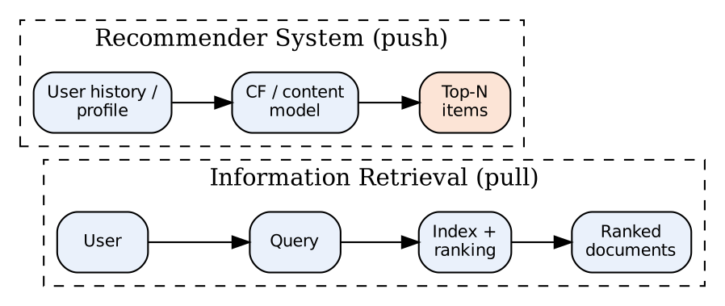
- IR path: user writes a query → index & ranking function → ranked documents.
- RS path: no query; the user’s history and similar users feed the model → personalised top-N items.

Similarities / overlap
- Both filter information overload and produce ranked outputs; both use similarity measures (cosine) and relevance feedback.
- Content-based recommendation uses IR techniques (TF-IDF profiles); modern search engines add personalisation (recommendation ideas) — e.g. YouTube combines search and recommendations.

Example
Typing “best thriller movies” on Google = IR. Netflix home page showing Mindhunter because you watched Narcos = RS.

Conclusion
IR answers an explicit query with relevant documents (pull); a recommender predicts preferences and pushes personalised items without a query — they complement each other.
Memory trick: “IR = Ask & Get (Pull); RS = Get without Asking (Push)”. Write at least 10 rows for 9-mark versions.

4.4 What are the different evaluation metrics for recommender system? ★★★
Write for: 12 marks (asked max 10) · Asked in: M24 Q8b [10], N24 Q8a [9], N25 Q8a [9] · Source: ⚠ Not found in your materials (notes give precision/recall/F-measure only for MIR, PDF p.48, and for search, PDF p.42). Standard textbook answer.

Definition
Evaluation metrics measure how good the recommendations are — how accurately ratings are predicted, how relevant and well-ranked the top-N list is, and whether recommendations are diverse, novel and useful for the business.
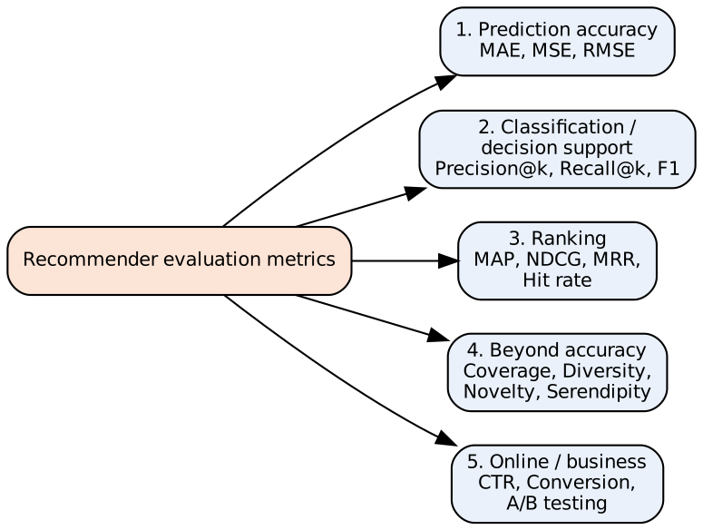

1. Prediction (rating) accuracy metrics
- MAE (Mean Absolute Error): MAE=1Nu,i​ǀru,i−ru,iǀ
- RMSE (Root Mean Squared Error): RMSE=1Nu,i​ru,i−ru,i2 — penalises large errors more (used in the Netflix Prize).
- $r_{u,i}$ = actual rating of user u for item i, ${\hat{r}}_{u,i}$ = predicted rating, N = number of test ratings. Lower is better.

2. Classification (decision-support) metrics for top-N lists
- Precision@k = $\frac{\text{relevant items in top }k}{k}$ — how many recommended items are useful.
- Recall@k = $\frac{\text{relevant items in top }k}{\text{total relevant items for the user}}$ — how many liked items were found.
- F1@k = $\frac{2⋅P⋅R}{P+R}$.

3. Ranking metrics (position matters)
- MAP (Mean Average Precision): mean over users of the average of precision values at each relevant position.
- NDCG@k: $DCG_{k}=\sum_{i=1}^{k}{\frac{rel_{i}}{\log_{2}\left(i+1\right)}}$, $NDCG_{k}=\frac{DCG_{k}}{IDCG_{k}}$ (IDCG = DCG of ideal ordering) — rewards relevant items at top positions; supports graded relevance.
- MRR (Mean Reciprocal Rank): mean of $1/\text{rank of first relevant item}$.
- Hit rate@k: fraction of users with at least one relevant item in top-k.

4. Beyond-accuracy metrics
- Coverage: % of catalogue items the system can recommend (catalogue coverage) or % of users who get recommendations.
- Diversity: how different the items in one list are (1 − average pairwise similarity).
- Novelty: recommending items the user did not already know (less popular items).
- Serendipity: surprising yet relevant recommendations.
- Personalisation / scalability / response time.

5. Online (business) metrics
- CTR (Click-Through Rate) = clicks ÷ impressions; conversion rate, revenue, watch time, retention — measured using A/B testing with real users. Also user studies (satisfaction surveys).

Worked example
Actual ratings (3, 5, 4), predicted (4, 4, 4):
- MAE = (1 + 1 + 0)/3 = 0.67; RMSE = $\sqrt{\left(1+1+0\right)/3}$ = 0.82.
Top-5 list [A, B, C, D, E]; relevant = {A, C, F}:
- Precision@5 = 2/5 = 0.4; Recall@5 = 2/3 = 0.67; F1 = 2(0.4)(0.67)/(1.07) = 0.5.
- MRR = 1/1 = 1 (A is relevant at rank 1).
- DCG = 1/log₂2 + 1/log₂4 = 1 + 0.5 = 1.5; IDCG (relevant at ranks 1, 2, 3) = 1 + 0.63 + 0.5 = 2.13 → NDCG = 0.70.

Offline vs online evaluation
Offline | Online
Historical data split into train/test | Live users, A/B test
MAE, RMSE, Precision@k, NDCG | CTR, conversion, retention
Cheap, fast, repeatable | Real impact, costly, slower

Conclusion
Recommenders are evaluated by accuracy (MAE, RMSE), top-N relevance (precision, recall, F1), ranking quality (MAP, NDCG, MRR), beyond-accuracy (coverage, diversity, novelty, serendipity) and online business metrics (CTR, A/B testing).
Memory trick: “A-C-R-B-O” → “A Car Runs Better Online”: Accuracy, Classification, Ranking, Beyond-accuracy, Online. RMSE > MAE when big errors exist — a common viva question.

4.5 Outline the steps to build a recommender system with an example. ★
Write for: 12 marks (asked max 10) · Asked in: M24 Q7a [10] · Source: IR Sem7.pdf, PDF p.53–57 (§6.2.1 Collaborative Filtering — user–item rating matrix, similar users; §6.2.2 Content Based Recommendation — CountVectorizer / document-term matrix, cosine similarity; §6.3 Knowledge Based Recommendation), PDF p.61 (case study: collaborative filtering on a dataset). Step list organised as a standard textbook pipeline.

Definition
Building a recommender system means creating a pipeline that collects user–item data, learns user preferences and generates personalised top-N suggestions, then evaluates and improves them.

Steps
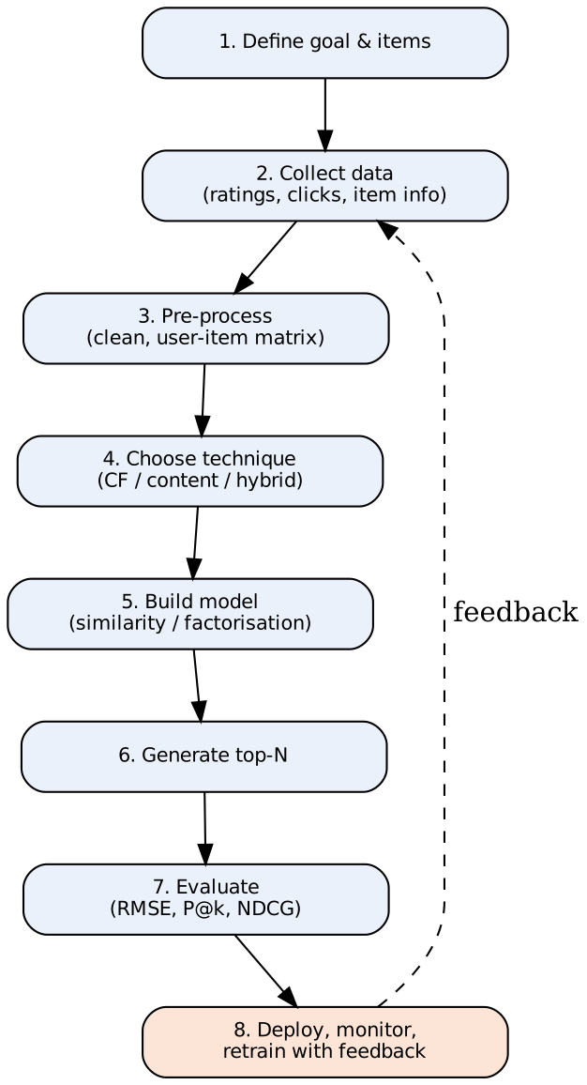
- Define the problem & goal: what to recommend (movies), to whom, which success metric (accuracy, CTR).
- Collect data: explicit (ratings, reviews) and implicit (clicks, views, purchases) feedback; item metadata (genre, cast, description); user demographics.
- Pre-process data: remove noise/duplicates, handle missing values, normalise ratings (mean-centring), build the user–item rating matrix (sparse) or TF-IDF / CountVectorizer item-feature matrix.
- Choose technique:
  - Collaborative filtering (user-based / item-based, matrix factorisation — SVD/ALS) — uses ratings of similar users.
  - Content-based — matches item features with user profile.
  - Knowledge-based — rules/constraints from user needs (e.g. budget).
  - Hybrid — combines them to solve cold start and sparsity.
- Build the model: compute similarity (cosine, Pearson) between users/items or learn latent factors; predict unknown ratings.
- Generate recommendations: predict scores for unseen items, filter seen/unavailable items, rank and return top-N.
- Evaluate: split train/test → MAE/RMSE, Precision@k, Recall@k, NDCG; online A/B testing (CTR).
- Deploy & improve: serve via API, monitor, collect new feedback, retrain periodically.

Worked example — user-based collaborative filtering (movies)
User | M1 | M2 | M3 | M4
Alice | 5 | 3 | ? | 1
Bob | 4 | 3 | 4 | 1
Carol | 1 | 1 | 5 | 5
Goal: predict Alice’s rating for M3.
Step A — cosine similarity on co-rated items (M1, M2, M4):
- sim(Alice, Bob) = $\frac{5⋅4+3⋅3+1⋅1}{\sqrt{35} \sqrt{26}}=\frac{30}{30.17}=0.99$
- sim(Alice, Carol) = $\frac{5⋅1+3⋅1+1⋅5}{\sqrt{35} \sqrt{27}}=\frac{13}{30.74}=0.42$
Step B — weighted prediction:
rAlice,M3=v​simAlice,v rv,M3v​simAlice,v=0.99×4+0.42×50.99+0.42=6.061.41≈4.3
Step C — recommend: predicted rating 4.3 (high) → recommend M3 to Alice. Bob (most similar) liked M3, so the result makes sense.
Step D — evaluate: hide some known ratings, predict them, compute RMSE; check Precision@k of the top-N list.

Content-based alternative (notes)
Item descriptions → CountVectorizer/TF-IDF → cosine similarity matrix between movies → recommend movies most similar to those the user liked.

Challenges
Cold start, sparsity, scalability, popularity bias / filter bubble, privacy, changing user tastes.

Conclusion
A recommender is built by defining the goal → collecting & preparing data → choosing CF/content/hybrid → building the similarity model → generating top-N → evaluating → deploying with feedback; user-based CF with cosine similarity is the simplest exam example.
Memory trick: “G-C-P-T-M-R-E-D” → “Good Cooks Prepare Tasty Meals, Really Excellent Dishes”: Goal, Collect, Pre-process, Technique, Model, Recommend, Evaluate, Deploy.

Last-Minute Revision Sheet — Unit 4
Topic | Key point to write
Recommender system | Predicts preference & suggests items without a query (push)
Four phases | CSAF: Collection (explicit/implicit) → Storage → Analysis (CF/CB/hybrid) → Filtering & recommendation
Feedback types | Explicit (ratings, reviews) vs implicit (clicks, views, purchases)
Techniques | Collaborative (user/item based, matrix factorisation), Content-based, Knowledge-based, Hybrid
CF prediction | $\hat{r}=∑sim⋅r/∑sim$; cosine / Pearson similarity
Problems | Cold start, sparsity, scalability, filter bubble
MIR definition | Retrieval of text, image, audio, video, graphs
MIR components | Representation, indexing, content-based, text-based, analysis, relevance feedback, evaluation
MIR models | Text-based, content-based feature vector (colour/texture/shape/MFCC), probabilistic/deep, MPEG-7
MIR types | SNGIV: Spoken audio, Non-speech audio, Graph, Image, Video
Semantic gap | Low-level features ≠ high-level meaning
IR vs RS | Query vs profile; pull vs push; same vs personalised results; precision/MAP vs RMSE/CTR
Accuracy metrics | MAE = mean abs error; RMSE = √mean squared error
Top-N / ranking | Precision@k, Recall@k, F1, MAP, NDCG = DCG/IDCG, MRR, hit rate
Beyond accuracy | Coverage, diversity, novelty, serendipity; online: CTR, A/B test
Build steps | Goal, Collect, Pre-process, Technique, Model, Recommend, Evaluate, Deploy
Mnemonics: CSAF (phases) · SNGIV + T-C-P-S (MIR) · “Pull vs Push” (IR vs RS) · A-C-R-B-O (metrics) · G-C-P-T-M-R-E-D (build steps).

Assumptions & Gaps
- Unit mapping: Q7/Q8 of every paper mapped to Unit 4 = syllabus Unit VI (IR Applications).
- ⚠ Not found in your materials (standard textbook answers): 4.1 the “four phases” list (several textbooks give different lists; the widely used Collection–Storage–Analysis–Filtering version is used; an alternative 3-phase version is Information collection → Learning → Prediction/Recommendation, which maps onto the same answer); 4.3 IR vs RS comparison; 4.4 recommender evaluation metrics. Model classification in 4.2 is partly standard.
- 4.2 merges “Explain multimedia IR models” and “Multimedia Information Retrieval” (N23 printed both in one paper). The answer covers both definition/components and models.
- 4.5 worked example data were made up by me for illustration (not from the notes).
- Citations give PDF page numbers of IR Sem7.pdf (two printed pages per PDF page) and section numbers printed in the notes.

